ENISA and FORTH met to boost collaboration and pave the way for joint cybersecurity projects in Crete

On 31 January 2019, ENISA was pleased to welcome a delegation from the Foundation for Research and Technology - Hellas (FORTH) to its new premises in Heraklion, Crete.

Published on February 01, 2019

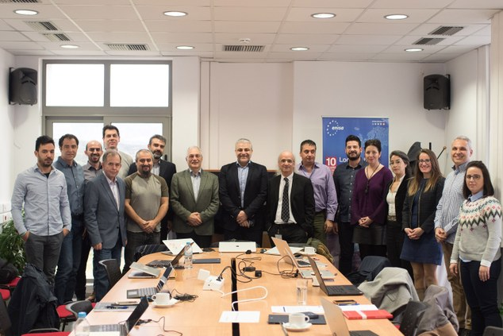

Tagged with

* [cybersecurity](https://www.enisa.europa.eu/search?Subject%3Alist=cybersecurity)

The two teams together with ENISA’s Executive Director, Prof. Udo Helmbrecht and the Chairman of the Board of Directors at FORTH, Prof. Nektarios Tavernarakis, exchanged information on cybersecurity projects and discussed ways to boost their collaboration following the signature of a Memorandum of Understanding (MoU) in September 2018.

Prof. Udo Helmbrecht said: “FORTH has a special place in the history of ENISA. It was our first home in Greece, and together we have been accomplishing many great projects for over 15 years now. Our joint work and dedication have established Heraklion as a European centre of cybersecurity excellence. We are honoured to be partners and friends in making Greece and Europe cyber safe. ”

Prof. Tavernarakis said: "FORTH keenly fosters and encourages close collaboration between ENISA and Research Teams at FORTH. We are proud to collaborate with ENISA, as this cooperation provides ample opportunity for scientific interactions and fruitful collaborations between the 2 Organisations. Specifically, the Institute of Computer Science of FORTH is actively pursuing research in the area of network and information security, offering considerable potential for synergies. As another example, FORTH, with 2 of its Institutes, the Institute of Molecular Biology and Biotechnology and the Institute of Computer Science, is the coordinator of one of the four national Precision Medicine Centers, that has been established here in Crete. Operating such a center poses unique challenges, relevant to sensitive data processing and storage. Other areas of potential collaboration are the graduate programmes in Bioinformatics and Biomedical Engineering which FORTH is coorganising together with the University of Crete.".

The meeting was the first of a series of steps that will help extend the cooperation between ENISA and FORTH, to the following activities in the area of cybersecurity:

* Jointly organised cybersecurity conferences and the NIS summer school;
* Cooperation in the areas of Life Sciences and Computer Science;
* Jointly organised exercises and training sessions by maintaining/sharing common knowledge and by exploiting available facilities and human resources in the new ENISA premises;
* Jointly organised research activities touching upon areas of common interest.

ENISA and FORTH are expected to drive many of the key projects outlined above from ENISA’s new building in Heraklion.

ENISA’s new state-of-the-art building in Heraklion, offering conference facilities and suitable IT infrastructure, has been accommodating ENISA’s staff based in Heraklion since December 2018. Its formal inauguration is expected this spring, with the participation of representatives from the Greek Government, Local Authorities and FORTH.

**Background**

In order to enhance the cooperation between ENISA and FORTH and help establish Heraklion as a European centre of cybersecurity excellence, a Memorandum of Understanding (MoU) was signed by both parties on 24 September 2018. ENISA and FORTH also jointly organised the fifth edition of ENISA-FORTH Network and Information Security (NIS) Summer School event in September.

These actions strengthen the excellent cooperation between the two organisations, which started with the establishment of ENISA in Heraklion in 2004.